**Results and discussion**

The statistical analysis revealed a significant association of political orientation (p < .05) on the language attitudes of the population of Palma de Mallorca toward Catalan and Spanish. In what follows, we will explore the results for some of the most relevant statements organized in six different categories according to their theme: language preference, language difficulty and enjoyment, language importance and usefulness, language policy and integration, cultural and identity aspects, and popular trends.

**Language preference**

When presented with the statement “I like that people use Catalan”, those who identified as progressive (far left, left, and center-left) showed a greater level of agreement with it. On the other hand, those who identified as conservative (center, center-right, and right), showed a stronger disagreement with it, as shown in Table #. Additionally, Figure # indicates that there was more consensus among progressive people around this statement. These findings with respect to Catalan were not the same in the case of Spanish. The analysis revealed no statistically significant differences between political orientations when presented with the statement “I like that people use Spanish”, as they all showed a high level of agreement with it.

**Table #.**

|  |  |  |  |  |
| --- | --- | --- | --- | --- |
|  | Estimate | Std. Error | t-Value | Pr(>|t|) |
| *Intercept* | 100.000 | 8.359 | 11.963 | < 2e-16 |
| Left | -7.667 | 8.948 | -0.857 | 0.39373 |
| Center-Left | -8.250 | 9.7120 | 0.849 | 0.3978 |
| Center | -35.600 | 12.949 | -2.749 | 0.00718 |
| Center-Right | -25.833 | 10.518 | -2.456 | 0.01590 |
| Right | -28.286 | 11.821 | -2.393 | 0.01873 |

Interestingly, people who identified themselves ideologically as centrist were the ones who showed the highest degree of disagreement with the statement, even higher than that indicated by those who identified themselves ideologically as center-right and right-wing. It is possible that this is due to the fact that the participants who identified their political ideology as center, in reality, were closer to more conservative and right-wing positions.

**Figure #. ADD FIGURE**

Similarly, when presented with the statement “I like listening to Catalan”, those who identified as progressive (far left, left, and center-left) showed a higher level of agreement with it as opposed to those who identified as conservative (center, center-right, and right), who showed a stronger sense of disagreement, as presented in Table #. Once again, those who identified themselves as centrist showed a greater level of disagreement with this statement than those who identified their political orientation as center-right, showing very similar results to those who indicated having a right political orientation. This seems to confirm that those who identified as centrist, in reality, were closer to more conservative and right-wing positions. The analysis also revealed considerably more consensus among participants with a more progressive ideology, as opposed to those with a more conservative ideology, as shown in Figure #. These findings with respect to Catalan were, once again, not the same in the case of Spanish. The analysis revealed no statistically significant differences between political orientations when presented with the statement “I like listening to Spanish”, as they all showed a high level of agreement with it.

**Table #**

|  |  |  |  |  |
| --- | --- | --- | --- | --- |
|  | Estimate | Std. Error | t-Value | Pr(>|t|) |
| *Intercept* | 100.000 | 8.821 | 11.336 | < 2e-16 |
| Left | -6.979 | 9.442 | -0.739 | 0.46169 |
| Center-Left | -8.650 | 10.249 | -0.844 | 0.40085 |
| Center | -36.600 | 13.666 | -2.678 | 0.00875 |
| Center-Right | -23.417 | 11.100 | -2.110 | 0.03757 |
| Right | -37.000 | 12.475 | -2.966 | 0.00383 |

**Figure #**

Similar results were also found when participants were presented with the statement “I like to use Catalan”. Those who identified as progressive (far left, left, and center-left) showed a significantly higher level of agreement with this statement as opposed to those who identified as conservative (center, center-right, and right), who showed a significantly lower level of disagreement, as presented in Table #. Once again, those who identified themselves as centrist showed a greater level of disagreement with this statement than those who identified their political orientation as center-right. The analysis also revealed considerably more consensus among participants with a more progressive ideology, as opposed to those with a more conservative ideology, as shown in Figure #. These findings with respect to Catalan were, once again, not the same in the case of Spanish. The analysis revealed no statistically significant differences between political orientations when presented with the statement “I like to use Spanish”, as they all showed a high level of agreement with it.

**Table #**

|  |  |  |  |  |
| --- | --- | --- | --- | --- |
|  | Estimate | Std. Error | t-Value | Pr(>|t|) |
| *Intercept* | 100.000 | 11.07 | 9.035 | 2.25e-14 |
| Left | -11.15 | 11.85 | -0.941 | 0.349273 |
| Center-Left | -19.350 | 12.860 | -1.505 | 0.13580 |
| Center | -43.60 | 17.15 | -2.543 | 0.012651 |
| Center-Right | -42.33 | 13.93 | -3.040 | 0.003076 |
| Right | -55.71 | 15.65 | -3.559 | 0.000588 |

**Figure #**

Contrary to the trend seen until now, when participants were presented with the statement “I feel compelled to use Catalan”, all political orientations showed a similar level of disagreement and the analysis revealed no statistically significant differences between them. However, when participants were presented with the statement “I feel compelled to use Spanish”, those who identified as progressive (far left, left, and center-left) showed a significantly higher level of agreement with this statement as opposed to those who identified as conservative (center, center-right, and right), who showed a significantly lower level of disagreement, as presented in Table #. Interestingly, however, the analysis also revealed more consensus among conservative participants, as opposed to those with a more progressive political ideology, as shown in Figure #.

Table #

|  |  |  |  |  |
| --- | --- | --- | --- | --- |
|  | Estimate | Std. Error | t-Value | Pr(>|t|) |
| *Intercept* | 82.57 | 13.00 | 6.351 | 7.77e-09 |
| Left | -19.11 | 13.92 | -1.373 | 0.17293 |
| Center-Left | -31.971 | 15.11 | -2.117 | 0.03697 |
| Center | -54.17 | 20.14 | -2.690 | 0.00848 |
| Center-Right | -74.07 | 16.36 | -4.528 | 1.76e-05 |
| Right | -60.86 | 18.39 | -3.310 | 0.00133 |

Figure #

Similar trends were found when participants were presented with the following statement: “I try to use Catalan whenever I can.” Participants who identified as progressive (far left, left, and center-left) expressed a stronger level agreement with it, as opposed to those who identified as conservative (center, center-right, and right), who showed a stronger sense of disagreement, as presented in Table #. Additionally, the analysis revealed a higher level of consensus among progressive participants as opposed to among conservative participants, as shown in Figure #.

Table #.

|  |  |  |  |  |
| --- | --- | --- | --- | --- |
|  | Estimate | Std. Error | t-Value | Pr(>|t|) |
| *Intercept* | 94.29 | 12.46 | 7.568 | 2.67e-11 |
| Left | -12.76 | 13.34 | -0.957 | 0.34093 |
| Center-Left | -16.19 | 14.47 | -1.118 | 0.26636 |
| Center | -48.89 | 19.30 | -2.533 | 0.01298 |
| Center-Right | -47.70 | 15.68 | -3.043 | 0.00304 |
| Right | -50.86 | 17.62 | -2.887 | 0.00484 |

**Figure #**

Opposite results were found when participants were presented with the following statement: “I try to use Spanish whenever I can.” Those participants who identified as progressive (far left, left, and center-left) indicated a higher level of disagreement with this statement. However, those who identified as conservative (center-right and right) showed a significantly higher level of agreement with it, as presented in Table #. Interestingly, those participants who identified as centrists, despite not being significant, seemed to somewhat disagree with this statement and adopt a more progressive positionality. In this case, the degree of consensus around this statement was higher among conservative participants, as shown in Figure #.

**Table #.**

|  |  |  |  |  |
| --- | --- | --- | --- | --- |
|  | Estimate | Std. Error | t-Value | Pr(>|t|) |
| *Intercept* | 44.143 | 13.897 | 3.176 | 0.00202 |
| Left | 11.315 | 14.876 | 0.761 | 0.44878 |
| Center-Left | 12.3071 | 16.1467 | 0.762 | 0.44786 |
| Center | 6.857 | 21.529 | 0.319 | 0.75081 |
| Center-Right | 54.857 | 17.487 | 3.137 | 0.00229 |
| Right | 40.143 | 19.653 | 2.043 | 0.04393 |

Figure #.

Political orientation was also associated with the level of agreement or disagreement with the following statement: “If I had children, I would like them to speak Catalan.” Consequently, participants with a more progressive political orientation (far left, left, and center-left) indicated a higher level of agreement with this statement, as opposed to those participants who identified as conservative (center-right and right), who strongly disagreed with it, as shown in Table #. In this case, however, people who identified as centrist showed a strong level of agreement with this statement and positioned themselves with those who identified as progressive. Overall, there was a stronger sense of consensus among centrists and progressive participants, as opposed to among those who identified as conservative, as shown in Figure #. Once again, these findings with respect to Catalan were not the same in the case of Spanish. When presented with the statement “If I had children, I would like them to speak Spanish”, all participants showed a similar level of agreement with it and there were no statistically significant differences between political orientations.

**Table #.**

|  |  |  |  |  |
| --- | --- | --- | --- | --- |
|  | Estimate | Std. Error | t-Value | Pr(>|t|) |
| *Intercept* | 100.000 | 8.743 | 11.438 | <2e-16 |
| Left | -6.938 | 9.359 | -0.741 | 0.46039 |
| Center-Left | -14.000 | 10.158 | -1.378 | 0.1715 |
| Center | -6.000 | 13.544 | -0.443 | 0.65880 |
| Center-Right | -22.750 | 11.001 | -2.068 | 0.04142 |
| Right | -46.000 | 12.364 | -3.720 | 0.00034 |

Figure #

Finally, when participants were presented with the statement “It is not good manners to answer in Catalan to someone who speaks to you in Spanish”, those who identified as progressive (far left, left, and center-left) indicated a stronger level of disagreement with it than those who identified as conservative (center-right and right), who tended to agree more with it, as presented in Table #. Once again, people who identified as centrist showed a stronger level of disagreement with this statement when compared to more conservative participants (center-right and right) and positioned themselves with those who identified as progressive. Overall, there seemed to be more consensus around this statement among those who indicated that their political orientation was either left or far left, as shown in Figure #. These findings with respect to Catalan were not the same in the case of Spanish. When presented with the statement “It is not good manners to answer in Spanish to someone who speaks to you in Catalan”, all political orientations showed a similar level of disagreement with it.

**Table #.**

|  |  |  |  |  |
| --- | --- | --- | --- | --- |
|  | Estimate | Std. Error | t-Value | Pr(>|t|) |
| *Intercept* | 16.714 | 14.598 | 1.145 | 0.25517 |
| Left | 5.452 | 15.627 | 0.349 | 0.72794 |
| Center-Left | 26.436 | 16.962 | 1.559 | 0.1225 |
| Center | 15.886 | 22.616 | 0.702 | 0.48417 |
| Center-Right | 51.952 | 18.369 | 2.828 | 0.00573 |
| Right | 47.143 | 20.645 | 2.283 | 0.02468 |

**Figure #.**

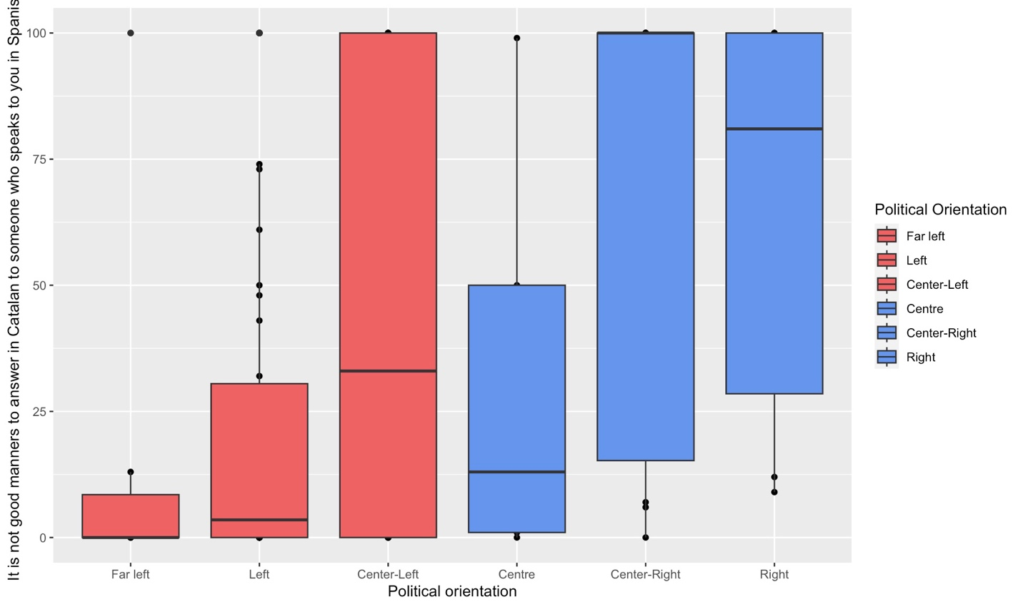

**Language difficulty and enjoyment**

Participants were presented with three statements related to the perceived level of difficulty of each language: “Catalan is a difficult language to learn”, “Spanish is a difficult language to learn”, and “An outsider will find it less difficult to learn Spanish than Catalan”. The analysis revealed no statistically significant differences among all six political orientations for any of the statements. This is due to the fact that all participants indicated a similar level of disagreement with them, meaning that political orientation is not associated with the perceived level of difficulty for Catalan and Spanish. By way of example, Figure # shows the level of agreement of all six political orientations with the statement “Spanish is a difficult language to learn.”

**Figure #**

Participants were also presented with eight statements regarding their perceived level of enjoyment with each language: “It is unpleasant to learn Catalan/Spanish,” “It is boring to learn Catalan/Spanish,” “Catalan/Spanish is a beautiful language,” and “Catalan/Spanish is a language that sounds bad.” Out of all these statements, only one of them generated statistically significant differences among all six political orientations: “Catalan is a beautiful language.” Accordingly, participants who identified as progressive (far-left, left and center-left) indicated a higher level of agreement with this statement, whereas those who identified as conservative (center, center-right, and right) indicated a higher level of disagreement, as presented in Table #. Additionally, the analysis revealed a greater consensus around this statement among progressive participants, as indicated in Figure #. These findings with respect to Catalan were not the same in the case of Spanish. When presented with the statement “Spanish is a beautiful language”, all political orientations showed a similar level of agreement with it.

**Table #**

|  |  |  |  |  |
| --- | --- | --- | --- | --- |
|  | Estimate | Std. Error | t-Value | Pr(>|t|) |
| *Intercept* | 97.429 | 10.850 | 8.980 | 2.94e-14 |
| Left | -10.387 | 11.614 | -0.894 | 0.37344 |
| Center-Left | -8.179 | 12.606 | -0.649 | 0.51808 |
| Center | -35.829 | 16.808 | -2.132 | 0.03567 |
| Center-Right | -36.512 | 13.652 | -2.674 | 0.00884 |
| Right | -42.429 | 15.344 | -2.765 | 0.00686 |

**Figure #.**

**Language importance and usefulness**

Participants were presented with five statements related to their perceived level of importance of each language: “Catalan/Spanish can become an important language in the European context,” “Catalan/Spanish is as important as English,” and “No language is more important than the other.” Out of all these statements, two showed statistically significant differences among political orientations. The first one was “Catalan is as important as English.” Participants who identified as more progressive (far-left and left) showed a higher level of agreement with this statement compared to those who identified as conservative (center, center-right, and right) and to those who said their political orientation was center-left, as presented in Table #. Interestingly, the degree of consensus was higher among those who identified as far-left-wing and right-wing, and lower among the rest of political orientations, especially among those who said their political orientation was center-left, as shown in Figure #.

**Table #.**

|  |  |  |  |  |
| --- | --- | --- | --- | --- |
|  | Estimate | Std. Error | t-Value | Pr(>|t|) |
| *Intercept* | 81.86 | 14.70 | 5.567 | 2.49e-07 |
| Left | -25.04 | 15.74 | -1.591 | 0.114941 |
| Center-Left | -61.21 | 17.08 | -3.583 | 0.000543 |
| Center | -48.26 | 22.78 | -2.119 | 0.036791 |
| Center-Right | -53.11 | 18.50 | -2.871 | 0.005074 |
| Right | -59.57 | 20.79 | -2.865 | 0.005156 |

**Figure #.**

The second statement that showed statistically significant differences among political orientations was “Spanish is as important as English.” Interestingly, participants of all political orientations but (center-left) one showed a significant level of consensus around this statement, as shown in Figure #. Additionally, the analysis revealed statistically significant differences among those participants who said their political orientation was far-left, left, and center-right, as presented in Table #.

Table #.

|  |  |  |  |  |
| --- | --- | --- | --- | --- |
|  | Estimate | Std. Error | t-Value | Pr(>|t|) |
| *Intercept* | 81.857 | 12.257 | 6.678 | 1.74e-09 |
| Left | -6.961 | 13.121 | -0.531 | 0.5970 |
| Center-Left | -34.357 | 14.242 | -2.412 | 0.017810 |
| Center | -15.657 | 18.989 | -0.825 | 0.4117 |
| Center-Right | 9.643 | 15.424 | 0.625 | 0.5334 |
| Right | -9.143 | 17.335 | -0.527 | 0.5991 |

Figure #.

Participants were presented with six statements related to the perceived level of usefulness of each language: “It is worth learning Catalan/Spanish,” “Studying Catalan/Spanish will be useful for me in the future to find a job,” “Catalan is used in some contexts and Spanish in some others,” and “Catalan is used in the countryside.” The analysis revealed no statistically significant differences among all six political orientations for any of the statements. This is due to the fact that all participants indicated a similar level of agreement or disagreement with them, meaning that political orientation is not associated with the perceived level of usefulness for Catalan and Spanish. By way of example, Figure # shows the level of agreement of all six political orientations with the statement “It is worth learning Spanish.”

Figure #.

**Language policy and integration**

When presented with the statement “It should be mandatory for all students from the Balearic Islands to take at least 50% of the subjects in Spanish”, participants who identified as more progressive (far-left and left) expressed a stronger level of disagreement compared to those who identified as conservative (center, center-right, and right), as presented in Table #. Additionally, the analysis revealed more consensus around this statement among those participants who identified as far-lefties and less consensus in all other political orientations, especially in the center-left, as shown in Figure #. Interestingly, these results were not the same in the case of Catalan. When presented with the statement “It should be mandatory for all students from the Balearic Islands to take at least 50% of the subjects in Catalan,” all political orientations showed a similar level of agreement with it.

Table #.

|  |  |  |  |  |
| --- | --- | --- | --- | --- |
|  | Estimate | Std. Error | t-Value | Pr(>|t|) |
| *Intercept* | 11.71 | 14.45 | 0.811 | 0.419671 |
| Left | 25.26 | 15.47 | 1.633 | 0.105807 |
| Center-Left | 36.79 | 16.79 | 2.191 | 0.0310 |
| Center | 51.69 | 22.39 | 2.309 | 0.023181 |
| Center-Right | 63.12 | 18.18 | 3.471 | 0.000788 |
| Right | 59.71 | 20.44 | 2.922 | 0.004368 |

Figure #.

When presented with the statement “Catalan should be a voluntary subject in schools and high schools in the Balearic Islands,” participants of all political orientations but one (right) expressed a similar level of disagreement. Those who identified as more conservative, on the other hand, expressed a significant level of agreement with this statement, as presented in Table #. Additionally, the analysis revealed consensus around this statement among participants of all political orientations but one (right), and especially among those who identified as centrists and far-lefties, as shown in figure #.

Table #.

|  |  |  |  |  |
| --- | --- | --- | --- | --- |
|  | Estimate | Std. Error | t-Value | Pr(>|t|) |
| *Intercept* | 1.4286 | 10.6799 | 0.134 | 0.89388 |
| Left | 13.5923 | 11.4322 | 1.189 | 0.23749 |
| Center-Left | 10.721 | 12.409 | 0.864 | 0.38981 |
| Center | 0.7714 | 16.5453 | 0.047 | 0.96291 |
| Center-Right | 10.4048 | 13.4386 | 1.518 | 0.13231 |
| Right | 45.000 | 15.1037 | 2.979 | 0.00368 |

Figure #.

When presented with the statement “Spanish should be a voluntary subject in schools and high schools in the Balearic Islands,” participants of all political orientations but one (center-left) expressed a similar level of disagreement. Those who identified their political orientation as center-left, on the other hand, expressed a significant level of agreement with this statement when compared to the rest, as presented in Table #. Additionally, the analysis revealed consensus around this statement among participants of all political orientations but one (center-left), and especially among those who identified as centrists, center-righties, and far-lefties, as shown in figure #.

Table #.

|  |  |  |  |  |
| --- | --- | --- | --- | --- |
|  | Estimate | Std. Error | t-Value | Pr(>|t|) |
| *Intercept* | 1.2857 | 10.5800 | 0.122 | 0.9035 |
| Left | 15.4018 | 11.3252 | 1.360 | 0.1771 |
| Center-Left | 24.464 | 12.293 | 1.990 | 0.0495 |
| Center | 0.5143 | 16.3904 | 0.031 | 0.9750 |
| Center-Right | 3.2143 | 13.3128 | 0.241 | 0.8097 |
| Right | 16.8571 | 14.96 | 1.127 | 0.2628 |

Figure #.

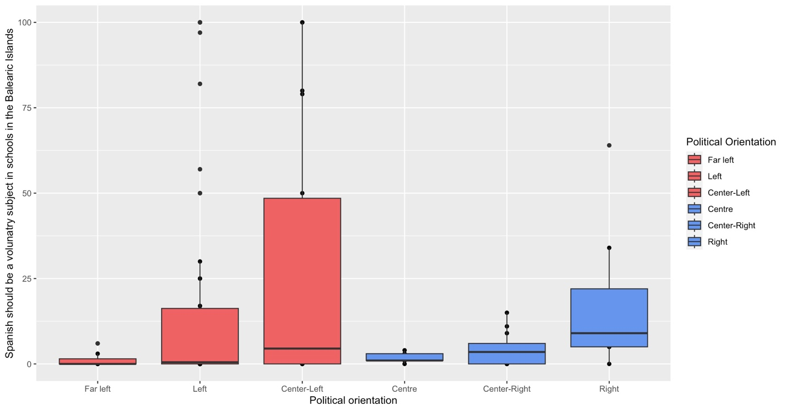

Political orientation was also associated with the level of agreement or disagreement with the following statement: “Catalan must be a requirement to hold a job in the public administration.” Consequently, participants with a more progressive political orientation (far left, left, and center-left) indicated a higher level of agreement with this statement, as opposed to those participants who identified as conservative (center, center-right and right), who strongly disagreed with it, as shown in Table #. Additionally, the analysis revealed more consensus around this statement among those participants who indicated their political orientation was far-left, center-right, and right, as shown in Figure #.

Table #.

|  |  |  |  |  |
| --- | --- | --- | --- | --- |
|  | Estimate | Std. Error | t-Value | Pr(>|t|) |
| *Intercept* | 100.00 | 13.67 | 7.314 | 8.93e-11 |
| Left | -27.15 | 14.63 | -1.855 | 0.066780 |
| Center-Left | -33.700 | 15.885 | -2.121 | 0.03654 |
| Center | -55.20 | 21.18 | -2.606 | 0.010662 |
| Center-Right | -74.17 | 17.20 | -4.311 | 4.03e-05 |
| Right | -73.57 | 19.33 | -3.805 | 0.000254 |

Figure #.

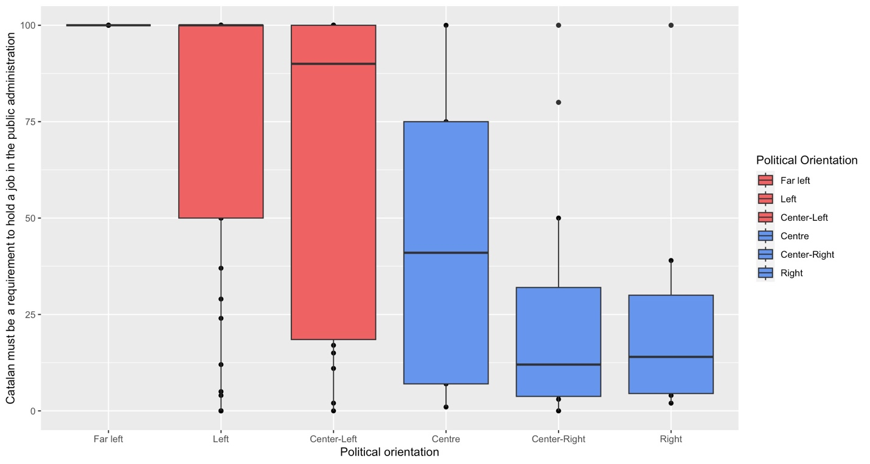

Finally, when participants were presented with the statement “Since we all speak Spanish, it is not necessary for people who come from other Autonomous Communities or Spanish-speaking countries to learn Catalan,” those participants who identified as progressive (far-left, left, and center-left) indicated an overall strong disagreement with it. On the other hand, those who identified as conservative (center, center-right, and right) expressed a strong agreement with this statement, as shown in Table #. Additionally, the analysis revealed more consensus around this statement among progressive participants, especially among those who said their political orientation was far-left and center left, as shown in Figure #.

Table #.

|  |  |  |  |  |
| --- | --- | --- | --- | --- |
|  | Estimate | Std. Error | t-Value | Pr(>|t|) |
| *Intercept* | 7..2857 | 11.2065 | 0.650 | 0.51721 |
| Left | 10.9018 | 11.9959 | 0.909 | 0.36581 |
| Center-Left | 0.6643 | 13.0208 | 0.051 | 0.9595 |
| Center | 29.5143 | 17.3611 | 1.700 | 0.09247 |
| Center-Right | 37.6310 | 14.1013 | 2.740 | 0.00738 |
| Right | 28.486 | 15.8484 | 1.794 | 0.07610 |

Figure #.

Cultural and identity aspects

When participants were presented with the statement “Catalan is an identity element of the Balearic Islands,” those who identified as progressive (far-left, left, and center-left) tended to agree more with it as opposed to those who identified as conservative (center, center-right, and right), as presented in Table #. Additionally, the analysis revealed more consensus around this statement among progressive participants, as shown in Figure #.

Table #.

|  |  |  |  |  |
| --- | --- | --- | --- | --- |
|  | Estimate | Std. Error | t-Value | Pr(>|t|) |
| *Intercept* | 100.00 | 10.60 | 9.430 | 3.28e-15 |
| Left | -12.13 | 11.35 | -1.068 | 0.28819 |
| Center-Left | -13.800 | 12.321 | -1.1120 | 0.26557 |
| Center | -37.20 | 16.43 | -2.264 | 0.02587 |
| Center-Right | -41.58 | 13.34 | -3.116 | 0.00243 |
| Right | -33.86 | 15.00 | -2.258 | 0.02630 |

Figure #.

Similarly, when participants were presented with the statement “Catalan is the language that should predominate in the Balearic Islands,” those participants who identified as progressive (far-left, left, and center-left) indicated an overall strong agreement with it. On the other hand, those who identified as conservative (center, center-right, and right) expressed an overall disagreement with this statement, as shown in Table #. Additionally, the analysis revealed a strong consensus among those who said their political orientation was far-left. On the other hand, the remaining political orientations showed greater variability in their responses, as shown in Figure #. These findings with respect to Catalan were not found in the case of Spanish. All political orientations but one (right) expressed an overall disagreement with respect to the idea of Spanish being the language that should predominate in the Balearic Islands.

Table #.

|  |  |  |  |  |
| --- | --- | --- | --- | --- |
|  | Estimate | Std. Error | t-Value | Pr(>|t|) |
| *Intercept* | 94.29 | 12.67 | 7.439 | 4.95e-11 |
| Left | -22.45 | 13.57 | -1.655 | 0.101305 |
| Center-Left | -25.54 | 14.73 | -1.734 | 0.08622 |
| Center | -69.09 | 19.63 | -3.519 | 0.000673 |
| Center-Right | -66.95 | 15.95 | -4.198 | 6.15e-05 |
| Right | -68.29 | 17.92 | -3.810 | 0.000250 |

Figure #.

Political orientation was also associated with the level of agreement or disagreement with the following statement: “All people living in the Balearic Islands should know Catalan and Spanish.” Consequently, participants with a more progressive political orientation (far left, left, and center-left) indicated a higher level of agreement with this statement, as opposed to those participants who identified as conservative (center, center-right and right), who tended disagreed with it, as shown in Table #. Additionally, the analysis revealed more consensus around this statement among those participants who indicated their political orientation was far-left, left, and right, as shown in Figure #.

Table #.

|  |  |  |  |  |
| --- | --- | --- | --- | --- |
|  | Estimate | Std. Error | t-Value | Pr(>|t|) |
| *Intercept* | 82.143 | 12.089 | 6.795 | 1.02e-09 |
| Left | 3.149 | 12.941 | 0.243 | 0.8083 |
| Center-Left | -3.493 | 14.046 | -0.249 | 0.8042 |
| Center | -36.743 | 18.728 | -1.962 | 0.0528 |
| Center-Right | -28.976 | 15.212 | -1.905 | 0.0599 |
| Right | -40.286 | 17.097 | -2.356 | 0.0206 |

Figure #.

Finally, when participants were presented with the statement “I live in the Balearic Islands and I have to know, study, and use Catalan,” those participants who identified as progressive (far-left, left, and center-left) indicated a strong agreement with it. On the other hand, those who identified as conservative (center, center-right, and right) tended to disagree more with this statement, as shown in Table #. Additionally, the analysis revealed a strong consensus among those who identified as progressive, whereas in the case of conservative participants there was more variability, as shown in Figure #. These findings with respect to Catalan were not found in the case of Spanish. All political orientations expressed an overall agreement with respect to the idea of having to know, study, and use Spanish when living in the Balearic Islands.

Table #.

|  |  |  |  |  |
| --- | --- | --- | --- | --- |
|  | Estimate | Std. Error | t-Value | Pr(>|t|) |
| *Intercept* | 100.00 | 11.41 | 8.762 | 8.51e-14 |
| Left | -12.52 | 12.22 | -1.025 | 0.30810 |
| Center-Left | -13.700 | 13.261 | -1.033 | 0.3042 |
| Center | -42.80 | 17.68 | -2.421 | 0.01744 |
| Center-Right | -38.25 | 14.36 | -2.663 | 0.00912 |
| Right | -38.86 | 16.14 | -2.407 | 0.01804 |

Figure #.

**Population trends**

When participants were presented with the statement “Fewer and fewer people know Catalan,” those participants who identified as progressive (far-left, left, and center-left) expressed a stronger agreement with it. On the other hand, those participants who identified as more conservative (center, center-right, and right) showed a greater disagreement with this statement, as presented in Table #. Additionally, the analysis revealed more consensus around this statement among those who said their political orientation was far-left, left, and right. The remaining political orientations showed greater variability in their responses, as shown in Figure #. This results with respect to Catalan were not the same in the case of Spanish. Overall, participants of all political orientations disagreed with the statement that fewer and fewer people know Spanish.

Table #.

|  |  |  |  |  |
| --- | --- | --- | --- | --- |
|  | Estimate | Std. Error | t-Value | Pr(>|t|) |
| *Intercept* | 99.86 | 12.57 | 7.947 | 4.38e-12 |
| Left | -28.73 | 13.45 | -2.136 | 0.03530 |
| Center-Left | -19.257 | 14.600 | -1.319 | 0.19041 |
| Center | -72.26 | 19.47 | -3.712 | 0.00035 |
| Center-Right | -50.02 | 15.81 | -3.164 | 0.00210 |
| Right | -47.00 | 17.77 | -2.645 | 0.00960 |

Figure #.

Similarly, when participants were presented with the statement “Catalan is in danger of disappearing in the Balearic Islands,” those participants who identified as progressive (far-left, left, and center-left) indicated an overall agreement with it. On the other hand, those who identified as conservative (center, center-right, and right) tended to disagree more with this statement, as shown in Table #. Once again, we see that those who identified as centrist expressed a stronger disagreement than those who said their political orientation was center-right or right. Additionally, the analysis revealed a strong consensus among those who said their political orientation was far-left and center. On the other hand, the remaining political orientations showed greater variability in their responses, as shown in Figure #. These findings with respect to Catalan were not found in the case of Spanish. All political orientations but one (right) expressed an overall disagreement with the idea that Spanish is in danger in the Balearic Islands.

Table #.

|  |  |  |  |  |
| --- | --- | --- | --- | --- |
|  | Estimate | Std. Error | t-Value | Pr(>|t|) |
| *Intercept* | 97.71 | 12.93 | 7.559 | 2.80e-11 |
| Left | -27.03 | 13.84 | -1.953 | 0.053815 |
| Center-Left | -25.164 | 15.020 | -1.675 | 0.09722 |
| Center | -84.51 | 20.03 | -4.220 | 5.68e-05 |
| Center-Right | -65.46 | 16.27 | -4.024 | 0.000116 |
| Right | -43.14 | 18.28 | -2.360 | 0.020373 |

Figure #.

Political orientation was also associated with the level of agreement or disagreement with the following statement: “People should put more effort into using Catalan.” Consequently, participants with a more progressive political orientation (far left, left, and center-left) indicated a higher level of agreement with this statement, as opposed to those participants who identified as conservative (center, center-right and right), who tended to disagree more with it, as shown in Table #. Additionally, the analysis revealed a strong consensus around this statement among those participants who indicated their political orientation was far-left, as shown in Figure #. The remaining political orientations showed greater variability in their responses.

Table #.

|  |  |  |  |  |
| --- | --- | --- | --- | --- |
|  | Estimate | Std. Error | t-Value | Pr(>|t|) |
| *Intercept* | 98.29 | 12.55 | 7.829 | 7.69e-12 |
| Left | -21.37 | 13.44 | -1.590 | 0.11518 |
| Center-Left | -23.786 | 14.586 | -1.631 | 0.1063 |
| Center | -62.09 | 19.45 | -3.192 | 0.00193 |
| Center-Right | -52.54 | 15.80 | -3.326 | 0.00126 |
| Right | -51.43 | 17.75 | -2.897 | 0.00470 |

Figure #.

Interestingly, when participants were presented with the statement “People should put more effort into using Spanish,” participants of all political orientations but two (center-right and right) expressed a similar level of disagreement with it. Those who identified their political orientation as center-right or right agreed significantly more with this statement, as presented in Table #. Additionally, the analysis revealed a similar degree of consensus among all political orientations, as shown in Figure #.

Table #.

|  |  |  |  |  |
| --- | --- | --- | --- | --- |
|  | Estimate | Std. Error | t-Value | Pr(>|t|) |
| *Intercept* | 21.000 | 12.542 | 1.674 | 0.0974 |
| Left | 3.563 | 13.426 | 0.265 | 0.7913 |
| Center-Left | 2.200 | 14.573 | 0.151 | 0.88033 |
| Center | 16.800 | 19.430 | 0.865 | 0.3895 |
| Center-Right | 33.833 | 15.782 | 2.144 | 0.0347 |
| Right | 32.000 | 17.737 | 1.804 | 0.0745 |

Figure #.

